How to check whether the purchaser is buying genuine tickets or not?

1. Please check the Logo of the Punjab Government before buying the ticket

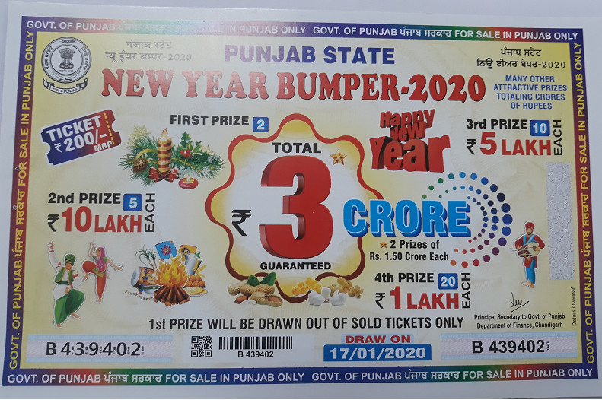

2. Please check the Government of Punjab is being written on all sides of tickets in English and Punjabi.

3. Please check the signature and official stamp of Principal Secretary to Government of Punjab, Department of Finance.

4. Please check the Bar code and Q R Code on each ticket.

5. Most important please check the ongoing bumper lottery draw on the official web site of the Government of Punjab i.e www.punjabstatelotteries.gov.in

